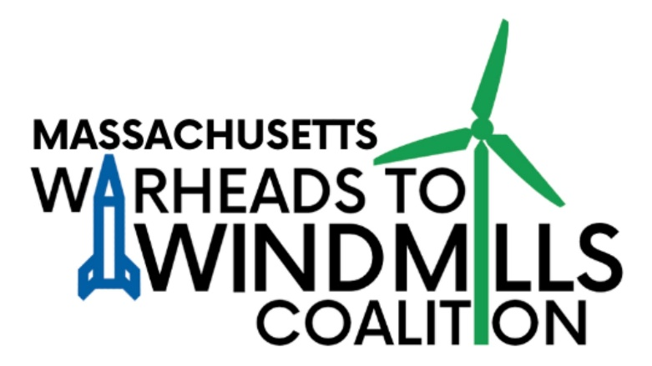
December, 4th, 2024

Massachusetts Warheads to Windmills Coalition
59 Gleason Road
Northampton, MA 01060
c/o Timmon Wallis
Timmon@NuclearBan.US
(631) 507-8686

Massachusetts State House, 24 Beacon St.
Office of the Governor, Room 280
Boston, MA 02133

Dear Governor Maura Healey,

We, the undersigned organizations, faith leaders and elected officials, representing concerned citizens from across the commonwealth, write to ask you to establish, by executive order, an Advisory Committee on Nuclear Weapons and Climate Change.

In 1985, Governor Dukakis established, by Executive Order 254, an Advisory Committee on Nuclear Weapons, to address the threat posed by the nuclear arms race to the residents of Massachusetts. Since then, the existential threat posed by nuclear weapons and the lack of progress in addressing this threat has continued to raise serious concerns.

The Bulletin of Atomic Scientists' "Doomsday Clock" was moved forward in 2018 to 2 minutes to midnight, the closest it has been to midnight since 1953 and closer, even, than during the Cuban Missile Crisis of 1962. The clock has continued to move closer to midnight since then, sitting now at 90 seconds to midnight due to the “many dimensions of nuclear threat” as well as “an ominous climate change outlook.” The atomic scientists who gave us the atom bomb think we are in more danger of a nuclear war than ever before. A new nuclear arms race is upon us with American nuclear spending leading the way while we are grossly behind our global goals in renewable energy efforts and reducing greenhouse gas emissions.

We are, of course, encouraged by steps that have been taken, both by the commonwealth and by the federal government, to address the threat posed by climate change. We are especially excited by the establishment of the Office of Climate Innovation and Resilience that you established on your first day as Governor. And yet the reality is that the threat of climate change is only getting worse globally and the people of Massachusetts remain unconvinced that we are doing enough as a nation to address this threat.

This is why we have been calling for the Commonwealth to establish a Citizens Commission on Nuclear Weapons and Climate Change. Rep. Lindsay Sabadosa and Sen. Jo Comerford have introduced versions of this commission bill in the past three legislative sessions, where they have garnered considerable support both inside and outside of the state house. The most recent iterations of the bills, H.738 and S.1488, were both voted favorably out of committee.

Nuclear weapons and climate change are both existential threats to every person in Massachusetts. An Advisory Committee on Nuclear Weapons and Climate Change could make Massachusetts an example to the rest of the country and the world in terms of managing the transition from an economy heavily reliant on the development, production and maintenance of nuclear weapons to an economy that is leading the way in green technologies and industries.

It could investigate and research the state’s involvement in the nuclear weapons industry, including what human and financial resources and skills could be effectively harnessed from that industry to address the climate crisis, and how to justly make that transition. By setting up an advisory committee and taking action on these issues now, you can help Massachusetts develop and implement leadership solutions to address the twin existential threats of nuclear weapons and climate change, which concern a clear majority of citizens across the commonwealth.

Thank you for your help with this, and for everything else you are, and have been, doing for the people of Massachusetts.

Yours,
The undersigned

Legislators and other elected officials:
Jim McGovern, US Representative, MA 2nd District
Jo Comerford, State Senator, Hampshire, Franklin and Worcester
Lindsay Sabadosa, State Representative, 1st Hampshire
Natalie Higgins, State Representative, 4th Worcester
Nicole LaChapelle, Mayor, Easthampton
Gina-Louise Sciarra, Mayor, Northampton
Joshua A. Garcia, Mayor, Holyoke
Tony Palomba, City-Councilor-At-Large, Watertown
Bob Armstrong, Select Board Chair, Conway

Faith leaders:
Martin Kelly, Associate Chaplain, College of the Holy Cross
The Rev. Dr. Peter Kakos, First Churches, Northampton
The Rev. Sarah Buteux, First Churches, Northampton
The Rev. Andrea Ayvazian

MA-based organizations:
Massachusetts Peace Action
350 Mass
MA Pax Christi
Greater Boston Physicians for Social Responsibility
Traprock Peace and Justice Center
Newton Chapter, Pax Christi
Pax Christi MetroWest, Boston Chapter
Watertown Citizens for Peace, Justice, and the Environment
Newton Dialogues on Peace and War
St. Susanna Chapter, Pax Christi
Brookline Students for Nuclear Disarmament
NuclearBan.US
Demilitarize Western Mass
Climate Action Now, Western Mass
Franklin County Continuing the Political Revolution
Better Future Project
Unitarian Universalist Mass Action Network
Cape Downwinders
Arlington United for Justice with Peace
New England Peace Pagoda
Springfield Climate Justice Coalition
Framingham Friends Meeting
Northampton Friends Meeting
Pax Christi Western Mass
CodePink Western Mass
MA Green-Rainbow Party
Treaty Alignment Campaign

